A Relaxing Training Script for Parents to Use with Their Children
When you feel tense, upset, or nervous, muscles in your body tighten. By practicing tightening certain muscles in your body, you will learn to relax them. Now get comfortable!
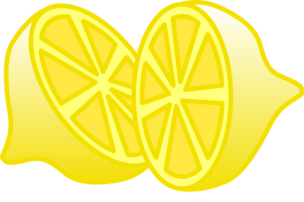 | Hands and Arms: Squeeze a Lemon  Pretend you have a whole lemon in each hand. Now squeeze it hard. Try to squeeze all the juice out! Feel the tightness in your hand and arm as you squeeze. Squeeze hard! Don’t leave a single drop. (Hold for 10 seconds). Now relax and let the lemon drop from your hand. See how much better your hand and arm feel when they are relaxed.
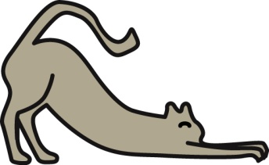 | Arms and Shoulders: Stretch Like a Cat  Pretend you are a furry, lazy cat and you just woke up from a nap. Stretch your arms out in front of you. Now raise them way up high over your head. Feel the pull in your shoulders. Stretch higher and try to touch the ceiling. (Hold for 10 seconds). Great! Let them drop very quickly and feel how good it is to be relaxed. It feels good and warm and lazy.
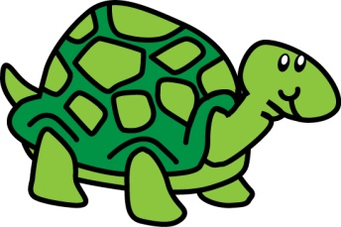 | Shoulders and Neck: Hide in Your Shell  Now pretend you are a turtle. Try to pull your head into your shell. Try to pull your shoulders up to your ears and push your head down into your shoulders. Hold it tight! (Hold for 10 seconds). Okay, you can come out now. Feel your shoulders relax.
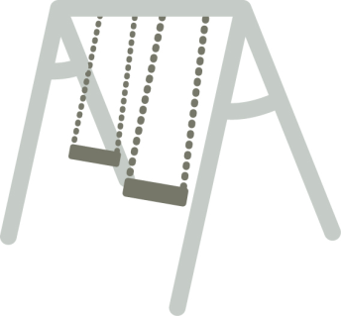 | Back: Swing Up High  Pretend you are on a swing at the park. Swing your upper body back and forth, back and forth. To get really high, use your arms to help you swing! Keep swinging! (Hold for 10 seconds). Great. You’re all done on the swing. Sit back and relax.
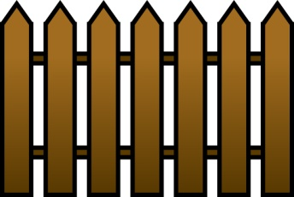 | Stomach: Squeeze Through a Fence  Now pretend that you want to squeeze through a narrow fence. You’ll have to make yourself very skinny if you’re going to make it through. Suck your stomach in, try to squeeze it against your back bone. Get it real small and tight. Hold it as tight as you can! (Hold for 10 seconds). Okay, you’ve made it! You got through the fence. Settle back and let your stomach come back out where it belongs.
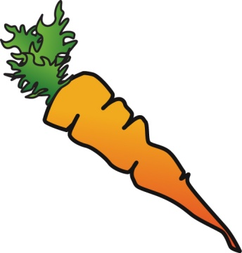 | Jaw: Chew That Carrot  Now, pretend that you are trying to eat a giant, hard carrot. It is very hard to chew. Bite down on it. As hard as you can. We want to turn that carrot into mush! Keep biting. (Hold for 10 seconds). Good. Now relax. You’ve eaten the carrot. Let yourself go as loose as you can.
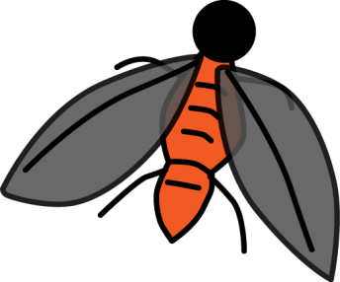 | Face and Nose: Get That Fly Off Your Nose  Here comes a pesky old fly and he has landed on your nose! Try to get him off without using your hands. Wrinkle up your nose. Make as many wrinkles in your nose as you can. Scrunch up your nose real hard and hold it just as tight as you can. Notice that when you scrunch up your nose, your cheeks and your mouth and your forehead and your eyes all help you and they get tight, too. (Hold for 10 seconds). Good. You’ve chased him away. Now you can just relax and let your whole face go smooth.
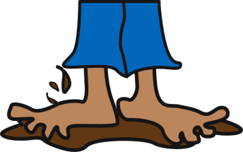 | Legs and Feet: Squish Your Toes in the Mud  Now pretend that you are standing barefoot in a big, fat mud puddle. Squish your toes down deep into the mud. Try to get your feet down to the bottom of the mud puddle. You’ll probably need your legs to help you push. Squish your toes down. Push your feet, hard! (Hold for 10 seconds). Okay, come back out now. Relax your feet, relax your legs, and relax your toes. It feels so good to be relaxed. No tenseness anywhere. You feel warm and tingly.
Tip: Giving your child a visual will help make practicing relaxation more enjoyable and easier for your child to follow. This can also provide a distraction during stressful doctor’s visits.

These materials are the product of on-going activities of the Autism Speaks Autism Treatment Network, a funded program of Autism Speaks. It is supported by cooperative agreement UA3 MC 11054 through the U.S. Department of Health and Human Services, Health Resources and Services Administration, Maternal and Child Health Research Program to the Massachusetts General Hospital. Website hosting, design, and maintenance provided by the Vanderbilt Kennedy Center.

