Principal – Steve Rauh Vice-Principals – S. Frith, J. Towers,

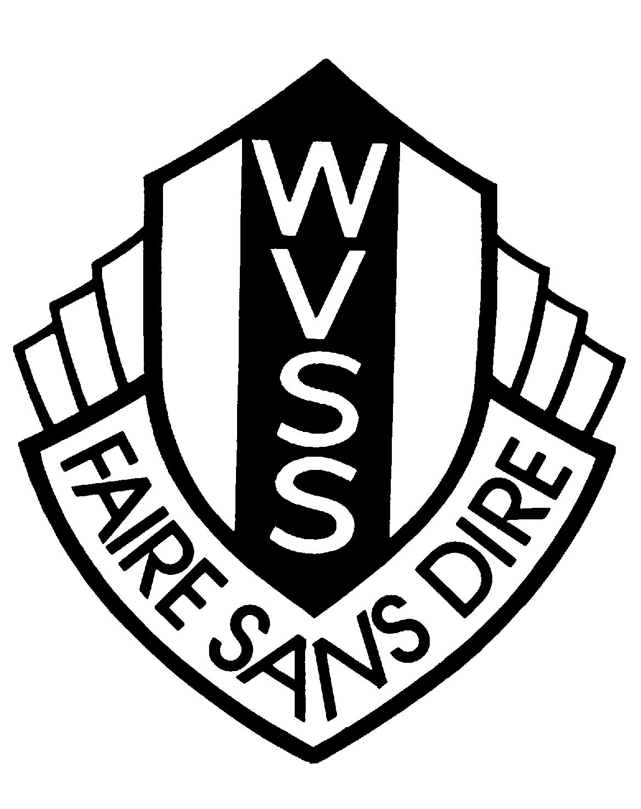 | 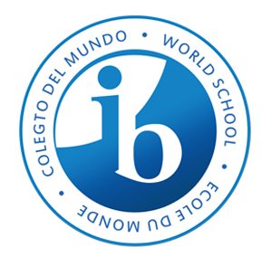  WEST VANCOUVER SECONDARY SCHOOL  1750 Mathers Avenue  West Vancouver, BC V7V 2G7  (604) 981-1100  Fax (604) 981-1101

The following dates are Confirmed Professional Days, Breaks, etc. for the year 2025-26.

- Thursday, August 28th, 2025 (Pro-D) – Kay Meek
- Friday, September 26th, 2025 (Pro-D)
- Tuesday, September 30th, 2025 – Truth & Reconciliation Day – School Closed
- Monday, October 13th, 2025 – THANKSGIVING DAY
- Friday, October 24th, 2025 (Pro-D)
- Tuesday, November 11th, 2025 – REMEMBRANCE DAY
- Monday, November 24th, 2025 – (Pro-D)
- Monday, December 22nd to Friday, January 2nd, 2026– Winter Break
- Monday, January 5th, 2026 – School Re-Opens for 2026
- Monday, January 30th, 2026 (District Pro-D)
- Friday, February 13th, 2026 (Reading Break)
- Monday, February 16th, 2026 - BC FAMILY DAY HOLIDAY
- Monday, March 16th to March 27th, 2026 – Spring Break
- Friday, April 3rd, 2026 – GOOD FRIDAY
- Monday, April 6th, 2026 - EASTER MONDAY
- Friday, May 15th, 2026 - (Pro-D)
- Monday, May 18th, 2026 – VICTORIA DAY HOLIDAY
- Friday, June 12th, 2026– Commencement for Grads 2026
- Friday, June 26th, 2026 – Administrative Day
- Wednesday, July 1st, 2026 – CANADA DAY!

