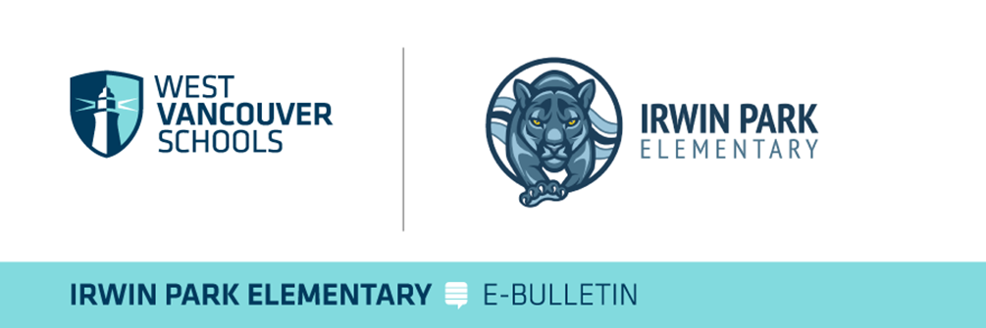  
**Irwin Park Elementary Family Newsletter**  
**E-Bulletin Update**  
**Date: Fri Jan 10th**

**Important Announcements**

**Stay Connected with Us!**  
Check out what’s happening at our school on social media:  
**Instagram:** [https://www.instagram.com/irwin_park_elementary/](https://can01.safelinks.protection.outlook.com/?url=https%3A%2F%2Fwww.instagram.com%2Firwin_park_elementary%2F&data=05%7C02%7Cableim%40wvschools.ca%7Ca4f12a6b90da47de572108dd31c96049%7Cd8013362a39e458b9457674cf091a797%7C0%7C0%7C638721463627576989%7CUnknown%7CTWFpbGZsb3d8eyJFbXB0eU1hcGkiOnRydWUsIlYiOiIwLjAuMDAwMCIsIlAiOiJXaW4zMiIsIkFOIjoiTWFpbCIsIldUIjoyfQ%3D%3D%7C0%7C%7C%7C&sdata=6NEugxLieo3rTTEZVLz67yMvPT3fTpUXRZYif5hU9hM%3D&reserved=0)

**Important Dates:**

* **Jan 15th:** Black Excellence Day in Canada
* **Jan 21st :** First Gr 7 Basketball League Game – Boys @ home vs WB
* **Jan 21st:** January IPPG Meeting - ONLINE
* **Jan 15h:** Admissions open at IP to incoming Gr 1 – 7 for Sept 2025
* **Jan 23rd**: Julia Robinson Math Festival – Family Evening! Times to be announced
* **Jan 30th** : Lunar New Year Celebration @ Irwin Park – Details to come!

**Principal’s Message**

Welcome back to all of our community members as we greet the new year and all that lies ahead. We have a lot of exciting events in store despite the short term. With our math festival taking place this month and the Gr 7 Basketball season starting up and a crop of new afterschool extracurricular activities there is lots to look forward.

We also wanted to extend our thanks to our Graduation Class of 2024. The legacy gift provided to Irwin Park Elementary from last year’s Grad Class was the painting of the IP Panther P.R.I.D.E. logo at the center court of our school gym. The finished product looks terrific and student feedback has been phenomenal! Check it out [here](https://can01.safelinks.protection.outlook.com/?url=https%3A%2F%2Fwww.instagram.com%2Fp%2FDEqV1DwzNez%2F%3Futm_source%3Dig_web_copy_link%26igsh%3DMzRlODBiNWFlZA%3D%3D&data=05%7C02%7Cableim%40wvschools.ca%7Ca4f12a6b90da47de572108dd31c96049%7Cd8013362a39e458b9457674cf091a797%7C0%7C0%7C638721463627595525%7CUnknown%7CTWFpbGZsb3d8eyJFbXB0eU1hcGkiOnRydWUsIlYiOiIwLjAuMDAwMCIsIlAiOiJXaW4zMiIsIkFOIjoiTWFpbCIsIldUIjoyfQ%3D%3D%7C0%7C%7C%7C&sdata=mw0VSxdt6eLND3OEn3mnz6CyijiswheIsjluERrJuos%3D&reserved=0) or drop by the gym the next time you are in the school to see this bold image and be inspired to show your Panther P.R.I.D.E.!

As we continue our focus on **Personal Digital Devices (PDDs)** from December, I’d like to encourage parents to reflect on their own device use while on the playground or school grounds, especially when students are present. Children learn by observing the adults around them, and they often model their behavior based on what they see. While it’s something we can all improve on, let’s make an effort this term to keep our phones away and in our pockets during pick-up and drop-off times. By doing so, we can foster a stronger sense of connection and community; which is our ultimate goal here at Irwin Park. Thank you for your continued support in helping us create an environment that encourages meaningful engagement!

**E-Bulletin Highlights**

* Save the Date: Jan 23rd Family Math Festiva Evening
* IP After School Activities: **SPACE in SOME PROGRAMS**
* West Vancouver Schools Registration Opens: Jan 15th-2025
* District **Digital Use Expectation** Reminder and Refresher

**Save The Date: Thurs Jan 23rd – Family Math Festival @ IP Returns!**

Back by popular demand, Irwin Park Elementary is excited to **host the Julia Robinson Mathematics Festival on Thursday, Jan 23rd.** With activities taking place throughout the day in the school gym and a **Family Math Night from 5:00 – 6:30 PM.**The festival, organized in partnership with the JRMF, aims to create joyful and engaging math experiences that build problem-solving and critical-thinking skills while fostering a growth mindset towards mathematics. During Family Math Night, parents and children from Kindergarten to Grade 7 are invited to explore puzzles and games in a collaborative atmosphere, supported by Grade 6/7 leadership students. This event provides an excellent opportunity for families to celebrate numeracy and transform traditional attitudes about math, making it fun, accessible, and meaningful for all. Mark your calendars and join us for an evening of learning and laughter!

**IP After School Activities Winter Term**

As many families may already be aware, our Winter Term After School and Lunch Hour Extra Curricular registration links have opened. Register early to avoid disappointment. **See the attached PDF for registration information.**

**Black Excellence Day – January 15th**

On **January 15th**, we celebrate **Black Excellence Day**, a time to honor the achievements, contributions, and resilience of Black Canadians throughout history. This day provides an opportunity to reflect on the significant impact of Black individuals and communities in shaping Canada’s story and fostering a more inclusive future.

Some notable Black Canadians include **Viola Desmond**, a civil rights activist who stood against racial segregation in Nova Scotia; **Dr. Carrie Best**, a trailblazing journalist and poet; **Portia White**, an internationally renowned opera singer; and **Donovan Bailey**, an Olympic gold medalist and Canadian sports icon. Their stories inspire us to recognize the importance of courage, innovation, and perseverance in overcoming barriers.

Throughout the day and this coming week, our morning announcements, our hallway screens, along with teachers and our teacher-librarian team will share stories and examples of **Black Excellence** through lessons, discussions, and library resources. These stories are not only a reminder of past accomplishments but also a call to action for continued progress and equity in our communities. Let’s come together to celebrate Black Excellence and the invaluable contributions of Black Canadians to our shared history and future.

**West Vancouver Schools Registration Opens January 15th, 2025**

K-12 registration for both in-district and out-of-district students opens on January 15! If you have students in your family or network who are looking to join our district, please help spread the word about this important date.

West Vancouver Schools offer a wonderful opportunity to be part of a community that values excellence in education. Our schools take pride in creating meaningful learning experiences and providing opportunities that support the growth, well-being, and success of every student.

To learn more about registration expectations and processes, please visit our admissions page: [West Vancouver Schools Admissions](https://can01.safelinks.protection.outlook.com/?url=https%3A%2F%2Fwestvancouverschools.ca%2Fadmissions%2F&data=05%7C02%7Cableim%40wvschools.ca%7Ca4f12a6b90da47de572108dd31c96049%7Cd8013362a39e458b9457674cf091a797%7C0%7C0%7C638721463627605199%7CUnknown%7CTWFpbGZsb3d8eyJFbXB0eU1hcGkiOnRydWUsIlYiOiIwLjAuMDAwMCIsIlAiOiJXaW4zMiIsIkFOIjoiTWFpbCIsIldUIjoyfQ%3D%3D%7C0%7C%7C%7C&sdata=wWkAz9viQtDd0Fkqm4wYB%2Bm2gPpl1yFSnG40pSMWdls%3D&reserved=0)

We look forward to welcoming new students and families to our vibrant and supportive school community!

**School and District Personal Digital Device Expectations**

As we reflect on the first four months of the school year, we’re proud to recognize the progress we’ve made together in implementing our Personal Digital Device (PDD) expectations. Thanks to the collective efforts of our students, families, and staff, we’ve seen a significant improvement in how digital devices are used in our schools. This has fostered more focused and engaged learning environments, aligning with our shared goal of supporting student success.

**Why We’re Doing This**

The purpose of these expectations is to minimize distractions and maximize learning opportunities. Digital devices, when used appropriately, are powerful tools for collaboration, creativity, and communication. However, ensuring they don’t interrupt instructional time or disrupt the learning environment remains a priority.

**What You Can Continue to Do**

1. **Be a Model of Balance and Healthy Digital Habits** – Put your phone down when speaking to your child and ensure you can reflect upon your habits while using social media; discuss the importance of the choice to “disconnect to connect”
2. **Reinforce Healthy Habits** - Continue encouraging a balanced approach to device use at home by promoting activities like reading, outdoor play, and family time.
3. **Model Consistency** - Show your support by modeling mindful device use when on the school grounds or in the school building AND during shared family time.
4. **Support School Communication** - Please avoid contacting your child during instructional time, this includes communication through phones and smartwatches. Remind them that non-urgent messages can wait until after school. If urgent communication is needed, please contact the school office.
5. **Stay Engaged** - Revisit the Parent/Guardian Guide to Personal Digital Devices to refresh your understanding of the expectations and discuss them with your child.

Thank you for your partnership and continued support in making this initiative a success.

Warm regards,

**Aron Campbell**

Principal

Irwin Park Elementary