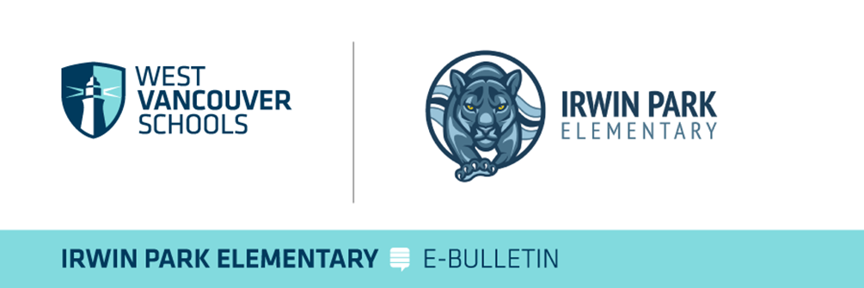  
 **Irwin Park Elementary Family Newsletter**  
**E-Bulletin Update**  
**Date: Friday, Dec 6th 2024**

**Important Announcements**

**Stay Connected with Us!**  
Check out what’s happening at our school on social media:  
**Instagram:**<https://www.instagram.com/irwin_park_elementary/>

**Important Dates:**

* **Dec 11th:** Irwin Park Winter Performance Concert – Gr 6 & 7 Band, Intermediate Choir
* **Dec 13th:** IPPG Santa’s Workshop Event in the Gym
* **Dec 13th:** Term 1 Learning Updates Released on My Ed
* **Dec 19th:** IPPG Staff Appreciation Luncheon – Click [here](mailto:ippgwestvan@gmail.com?subject=How%20can%20I%20contribute?) to see how you can contribute
* **Dec 19th:** Charity Hot Chocolate Sale – Gr 6 & 7 Leadership Team
* **Dec 20th:** Last Day of School Before Winter Break - 12 Noon Dismissal

**Principal’s Message**

As many families may be already aware, our Winter Term After School and Lunch Hour Extra Curriculars registration links have opened. Please see the email that was sent out on Thursday Dec 5th with the list of activity options. Register early to avoid disappointment. We have added Art Mania: Claymation to the list for Friday at lunch hours. Pls see the registration information attached.

This morning, as I drove to work, I listened to the [CBC Radio One Holiday Campaign](https://www.cbc.ca/kind/bc), and this year’s theme, [“Make the Season Kind”](https://youtu.be/hoavkT8oZeI) resonated.

At Irwin Park, we’re proud to support the meaningful initiatives led by our Grade 6/7 Leadership Team—*like Santa’s Workshop, the Winter Clothing Drive, and the Charity Hot Chocolate Sale on December 19th*. Your generosity has already been incredible, and we thank you for it. This campaign, however, offers an additional way to make a difference. The holidays can sometimes become a time of excess, but for many in our province, it’s a struggle to meet even basic needs like food and shelter.

I encourage you to learn more about “Make the Season Kind” and consider donating via the link below. Every contribution, no matter the size, has a real impact on those who need it most and sets a powerful example of compassion and generosity for our children here at Irwin Park and reflect the values embodied by Panther P.R.I.D.E.

<https://www.foodbanksbc.com/2024-cbc-make-the-season-kind>

<https://foodbank.bc.ca/events/cbc-day-2024/?form=joy>

Let’s continue to make kindness the heart of this season. Thank you for your consideration.

**E-Bulletin Highlights**

* **IP After School Activities Open for Registration: NOW OPEN**
* **Irwin Park Winter Concert Date – Dec 11th at 5:00 pm**
* **Santa’s Workshop Dec 13th – Donations and Volunteers Needed!**
* **Winter Weather Protocols at Irwin Park and in WVSD**

**Winter Concert at Irwin Park – Admission by Donation**

Mark your calendars for our Winter Concert on **Wed, Dec 11th at 5:00 pm**! Ms. King and her students have been working hard and are excited to share their progress. Guests are encouraged to bring a non-perishable food item to donate to the Harvest Food Project, or a small cash donation to support our Irwin Park Community Garden. **This early evening event will involve** our **Concert Bands and our Intermediate Choir, who** will be showcasing their talents and raising holiday cheer. This year’s concert will only involve our concert band, beginner band and Intermediate Choir.

**Santa’s Workshop Needs Donations!**

Our beloved Santa’s Workshop is returning! We need donations of new or 'like new' items for students to purchase as gifts for their families. Please drop off donations at the front entrance until December 13th. Santa’s Workshop needs donations of new or 'like new items' that will be offered for sale to students at a discounted price to give as gifts to their family. Do you have items that no longer bring you joy? Are your cupboards overflowing and making you feel overwhelmed? We can help! **Donations for Santa's Workshop are being collected now, and through to December 13, in the boxes that have been placed at the front entrance outside the office.**

We are also still looking for volunteers to support our Santa’s Workshop will begin set up on the afternoon of Thurs Dec 12. Those interested can reach out to our IPPG at [**ippgwestvan@gmail.com**](mailto:ippgwestvan@gmail.com) or the amazing Claire Wang our Santa’s Workshop Lead Elf!

**School and West Van School District Communication – BY TEXT/SMS**

As part of our ongoing effort to keep parents informed and aware of any school emergency, **such as closure, power outages or severe weather or safety alerts we offer an SMS/Text Message option for all parents.** Please text a “Y” or “Yes” to 978338 to ensure you are on the list.

**Please be sure to check the** [**school district website**](http://westvancouverschools.ca/) **for the most current information on school closures.**

Thank you for your ongoing support and flexibility. Should you have any questions please reach out to our office.

Warm regards,

**Aron Campbell**

Principal

Irwin Park Elementary