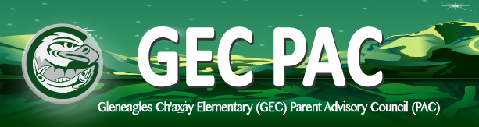
PAC Meeting Agenda
Wednesday, January 13, 2021 6:30pm via Zoom link

Adoption of minutes from previous meeting
Adoption of Agenda

6:30 Lisa Fairburn, PAC Chair Report
Kelly Kerklaan, Treasurer’s Report
Kirstie Simpson, Hot Lunch Coordinator’s Report
Wendy Human, DPAC Report & Trustee Liason Meeting Report
6:55 Aron Campbell, Principal’s Report

7:15 Special Guest Speaker - Chris Kennedy, Superintendent of Schools

8:00 Adjournment

Next Meeting: Wednesday, February 26th 6:30pm

Fundraising Reminder: our links are still active; please take a moment to click on the link to see who we are partnering with. Fundraising Link

A note from Mr. Campbell:
“Really nice thank you to the staff and families of GEC for the North Shore Family Food Drive from the host school.
Expressing their sincerest gratitude. Please know the efforts of every family made a huge difference. Have a great day and thanks again.”
***see attached pic

Remember: All parents and guardians of children enrolled at Gleneagles Ch’axay Elementary are members of the GEC PAC. We encourage everyone to attend and welcome feedback and questions on how to give our children the best experiences we can.

We look forward to seeing you!

