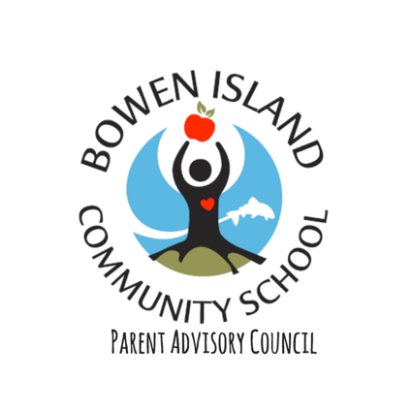
December 2017 PAC Fundraising Report
In December PAC ran three first time fundraisers very successfully; with a total income of: $5771. Funds will directly and fully contributed to the the education, learning and growth of Bowen Island’s children and community as a whole.

Photos with Santa

3rd December
Location : CSA Craft Fair
Amount raised: $541
Costs: ZERO
Total Income: $541
Event summary: 27 Families booked online though Slotted to book a photo with Santa at the cost of $20. Photographer, set designer, Santa and day of help all volunteer. The idea was to take the stress of city Santa phots away from Bowen families while supporting local learning projects consecutively.
NOTES
This was a first time event, we slotted 3 minutes per photo which proved an accurate time slot. Lots of room for walk ins.
Suggestions for 2017
(very much open to suggestions and discussion)
- Envelopes for photos
- Increase family participation
- Signage at the Craft Fair
- Stress that this will be an annual event (?)
- Lower Price, to accommodate more families (?)
- Bigger effort on Santa area decoration and feel of Santa Grotto, including candy cane hand out, decoration on common/library area
Martinis with Santa
10th December
Location: Doc Morgan’s
Amount raiser: $330
Costs: ZERO
Total income: $330

Event summary: BICS Christmas party featuring Santa and DJ. Tickets sold at $10 for 100% profit of BICS. Santa and music paid for by Doc’s. Bar and food sale under Doc’s. A space for BICS parents and friends to get together and celebrate the holidays.

NOTES
Over all a fun let lose night. This was a first time event, terrible weather greatly effected numbers to event. Poor turn out to event theme.

Suggestions for 2017
(very much open to suggestions and discussion)
- Lower ticket price ($5?)
Bigger impute from PAC to make a PAC event apposed to a Doc’s event.
Door prize
- Games
- Raffle
- Theme
- Use BCC prototype for Wilde Child Party

Holiday 50/50 draw
01st December – 31st December
Location: Bowen
Amount Raised: $9990
(two unsold ticket books lost by sellers)
Cost: printing/ posters ($257.37)
Total income: $4642.63
Event summary: Someone wins $5k on New Years Day, while supporting BICS project. 50/50 draw from 01st December – 31st December. Funds raised for all ages playground at BICS.

Suggestions for 2017
(very much open to suggestions and discussion)
- Start date 12th November
Cut off date 24th December
Have extra books printed without numbers incase of lost books as Office closed over Christmas
Instead on individuals selling sell at holiday events, such as Light Up Bowen, legion and Little Red Church Craft Fairs
- People to sell outside General Store
- Someone who is NOT Sasha to read the rules.
Rules and “how to sell” leaflet handed out to all sellers with tickets including what to do with unsold tickets and selling suggestions.
Not the same person distributing as collection
- Cut back on number of people selling
Cut back on printing costs
***What will the 2017 50/50 funds be used for**

TOTAL DECEMBER FUNDS RAISED:
$5513.63

